INTERNATIONAL SPY MUSEUM
COLLECTIONS OVERVIEW

Through its extensive collection, the International Spy Museum illustrates the real-life stories of intelligence professionals and offers insight into the overall impact of spycraft on world history as well as public perception of espionage practices. The goal of the collection is to enhance the Museum’s dynamic and comprehensive interpretation of international espionage and provide the most extraordinary learning experience for visitors. Ongoing research into the history of the tradecraft and contemporary role of espionage continues to reinforce the integrity of the Museum’s collection.

Among the collection’s highlights are:

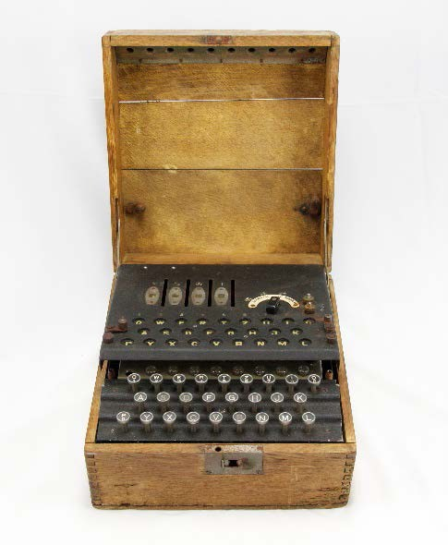
Four Rotor Japanese Enigma Machine (Germany)

Enigma was a computation machine that allowed operators to send scrambled messages. Knowledge of the appropriate rotor setting would permit those who received the messages to decipher the code. Enigma communications were thought to be impossible to crack...until the Allied forces were able to crack it. This machine was found at the end of WWII in a French submarine base where Germans were preparing to ship the Enigma to Japan.

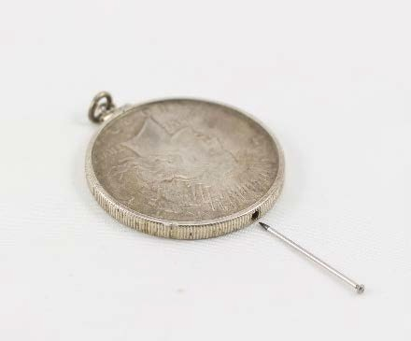
1922 Silver Dollar with Suicide Pin (US)

This pin was made by the CIA for use in the U2 program. Each coin had a spring-loaded pin that was laced with lethal toxin. It was created for the pilot in the event that he would choose death over capture and possible torture. This pin belonged to Francis Gary Powers, who was shot down in the 1960 U2 incident.

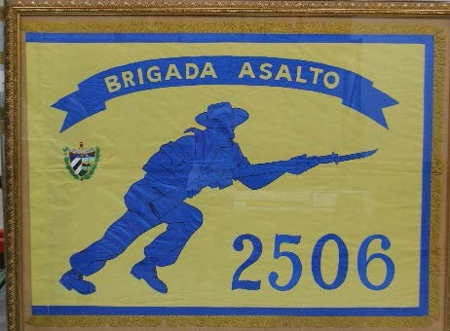
Bay of Pigs Flag (US)

After Communist Fidel Castro took power in Cuba, the CIA trained and equipped a group of Cuban exiles to infiltrate the island and start a revolution. The 2506 Assault Brigade was meant to fly this flag as a symbol of victory in Havana following the 1961 invasion attempt. When the attempt failed, the flag was later presented to President Kennedy by the survivors of the 2506 Brigade.

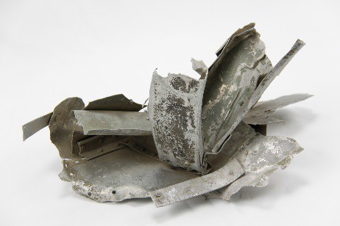
Wreckage of Powers’ U-2 Plane (US)

Francis Gary Powers was shot down over the Soviet Union while conducting an espionage mission in Soviet airspace. This forced the US government to admit that they had been flying missions over the USSR and created additional tension between the two superpowers. Powers was later traded in the first-ever “spy swap” between the United States and the Soviet Union. This type of plane is still in use today.

Vial of Heavy Water (Norway)
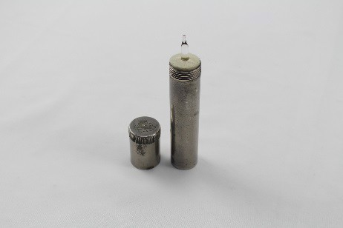

During WWII, heavy water, or deuterium oxide, was a key component in Germany’s atomic bomb research. It was produced in only a handful of places around the world, including the Norsk Hydro power plant in Norway. As part of Operation Gunnerside, Norwegian members of the British Special Operations Executive (SOE) successfully attacked the plant to slow production of deuterium oxide and keep it out of Nazi hands. The plant is believed to have presented these vials to the saboteurs following the war.

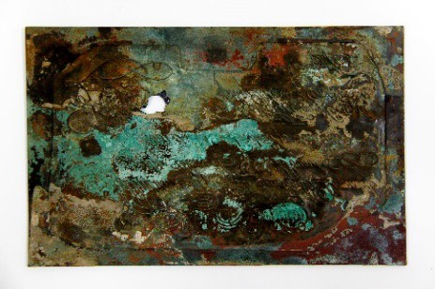
Operation Bernhard Forged Currency (Germany, SD issue)

Operation Bernhard was a plot devised during World War II by the Nazi SD (Sicherheitsdienst) intelligence service to upset the British economy by distributing large amounts of forged currency. The printing plate, created by master Jewish engravers imprisoned in concentration camps, were so successful that they remained undetected until the early 1950s. Their discovery caused the British government to change the design of their notes.

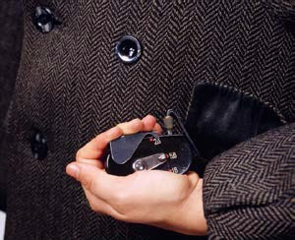
Coat with Buttonhole Camera (USSR, KGB issue)

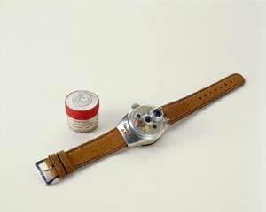
The KGB used small, lightweight F21 cameras for various methods of clandestine photography. Concealing the camera behind coat buttons proved very effective. The camera lens was hidden behind a false button on the front of the user’s coat. When the remote shutter release was triggered, connected to the lens by a thin cable from a coat pocket, the center of the false button opened briefly to take the photograph.

Steineck ABC Wristwatch Camera (Germany)

This cleverly disguised subminiature camera allowed an operative to take photographs while pretending to check his watch for the time of day. It used a circular piece of film with six exposures.

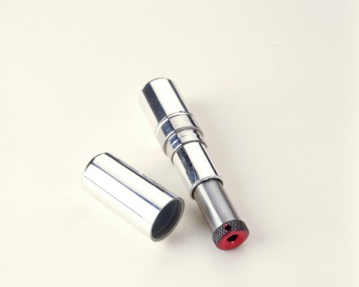

Lipstick Pistol (USSR, KGB issue)

Referred to as “The Kiss of Death,” the lipstick pistol was employed by KGB operatives during the Cold War. This 4.5 mm single shot weapon was disguised as a tube of lipstick, easily hidden in a purse. The existence of such a weapon was first detected at a border crossing into West Berlin.

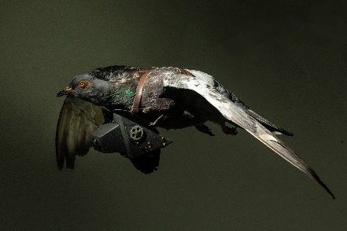
Aerial Surveillance Camera (Germany)

Pigeons with tiny cameras were commonly released over military sites in World War I. As the birds flew, the cameras continuously clicked away, snapping pictures which were developed and interpreted when the pigeons reached their destinations.

